Background

Coronavirus disease (COVID-19) is an infectious disease caused by a newly discovered coronavirus that started in Wuhan,China, and has become pandemic. From December 2019 until now days, it has expanded to touch every corner of the globe. Millions of people around the world [have been sickened](https://abcnews.go.com/Health/coronavirus-map-tracking-spread-us-world/story?id=69415591) and hundreds of thousands of others have died.

The World Health Organization has declared the virus a global [health](https://abcnews.go.com/alerts/obamacare) emergency and rated [COVID-19](https://abcnews.go.com/Health/Coronavirus)'s global risk of spread and impact as "very high," the most serious designation the organization gives.

Wireframe

The project contains four pages and has no significant difference between the web and mobile version. The wireframes page were designed as follow:

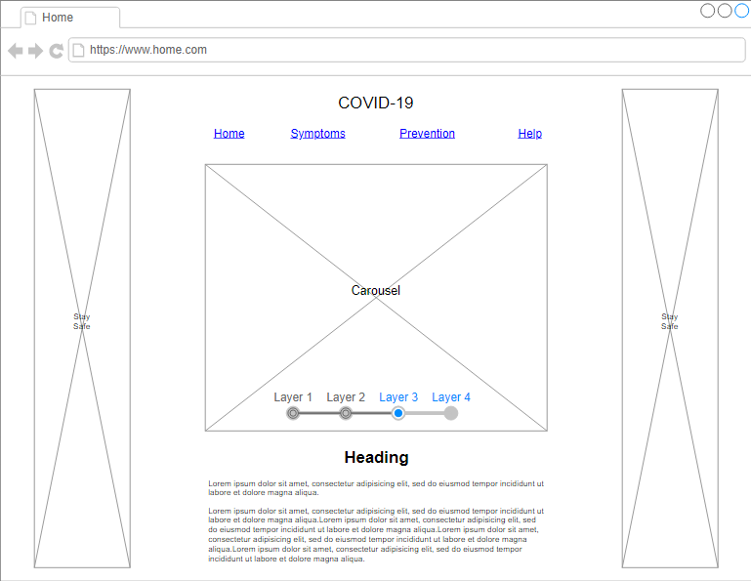

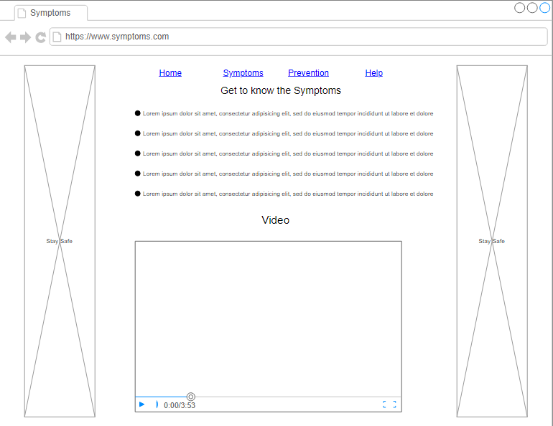

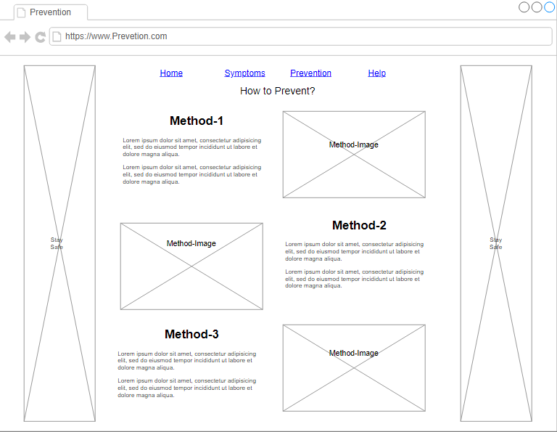

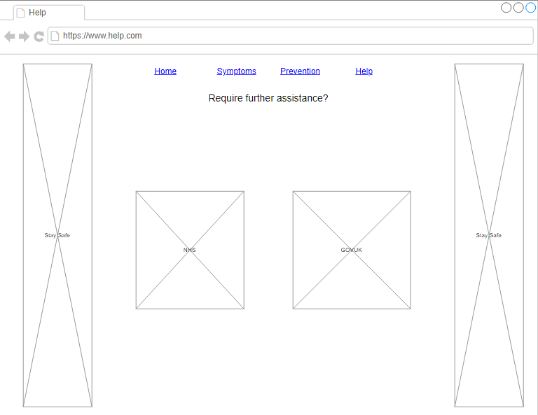

Colour Choices

The colour choices where based on the most used colours to represent health. Although blue has the first place as the most used, green was used to give it a better experience combined with rest of the images.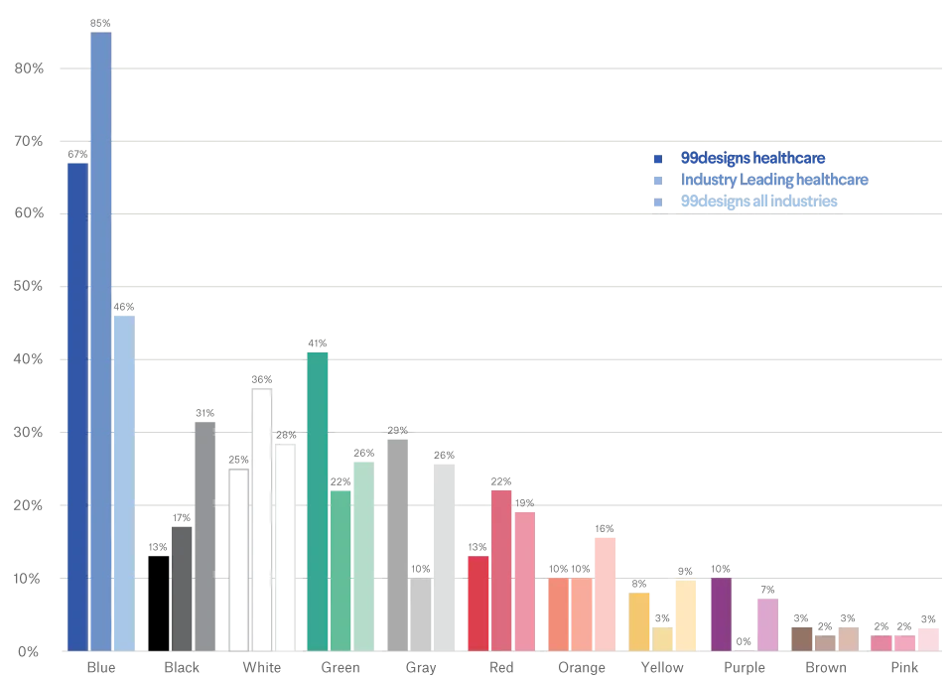**99designs, (2020), The logo colours of healthcare.** [**https://99designs.ca/logo-design/psychology-of-color/healthcare**](https://99designs.ca/logo-design/psychology-of-color/healthcare)

Accessibility

The website is completely functional with keyboard only. It also contains well specified “alt” in each image making it understandable for users with visual disabilities that may use screen reader. Pages are resizable making it fit any device. The colour contrast went through the WCAG tests. The carousel has only single sentences making it easier to read and avoiding problems as the content disappear before having time to read. It also has forms of navigating through it manually if needed.

Gdpr

The website only display information and does not collect any type of data from the user, neither cookies, thus a privacy policy is not needed.

Distance Selling

The website does not offer any type of service whatsoever. This way distance selling measures were not taken for not being necessary.

Evaluation

For the time being COVID-19 has no cure and was recently approved a vaccine with a certain percentage of effectiveness. Thus, the website aims to create an awareness about the virus and provide help with some instructions, guidelines, and useful links to other websites. The website design was based on other health organization websites and using the colours generally chosen for this type of topic, making the information clear and simple to understand. To guarantee the better experience to the user the website was tested with breakpoints using google chrome developer tools and has a new set of Cascadian style sheet for each of these new breakpoints.